14. React-HOL

ThemeContext.js
import React from 'react';

const ThemeContext = React.createContext('light'); // default theme is light

export default ThemeContext;

App.js:
import React, { useState } from 'react';
import EmployeeList from './EmployeesList';
import ThemeContext from './ThemeContext';

function App() {
const [theme, setTheme] = useState('light'); // state for theme

return (
<ThemeContext.Provider value={theme}>
<div className="App">
<h1>🌐 Employee Management</h1>
<button onClick={() => setTheme(prev => prev === 'light' ? 'dark' : 'light')}>
Toggle Theme
</button>
<EmployeeList />
</div>
</ThemeContext.Provider>
);
}

export default App;

EmployeesList.js
import React from 'react';
import EmployeeCard from './EmployeeCard';

const EmployeesList = () => {
const employees = [
{ id: 1, name: 'Alice', role: 'Developer' },
{ id: 2, name: 'Bob', role: 'Designer' },
];

return (
<div>
<h2>Employee List</h2>
{employees.map(emp => (
<EmployeeCard key={emp.id} employee={emp} />
))}
</div>
);
};

export default EmployeesList;
EmployeeCard.js
import React, { useContext } from 'react';
import ThemeContext from './ThemeContext';

const EmployeeCard = ({ employee }) => {
const theme = useContext(ThemeContext);

const buttonStyle = {
backgroundColor: theme === 'light' ? '#fff' : '#333',
color: theme === 'light' ? '#333' : '#fff',
};

return (
<div style={{ border: '1px solid gray', padding: '10px', margin: '10px' }}>
<h3>{employee.name}</h3>
<p>{employee.role}</p>
<button style={buttonStyle}>View Profile</button>
</div>
);
};
export default EmployeeCard;
OUTPUT:
Before Toggling theme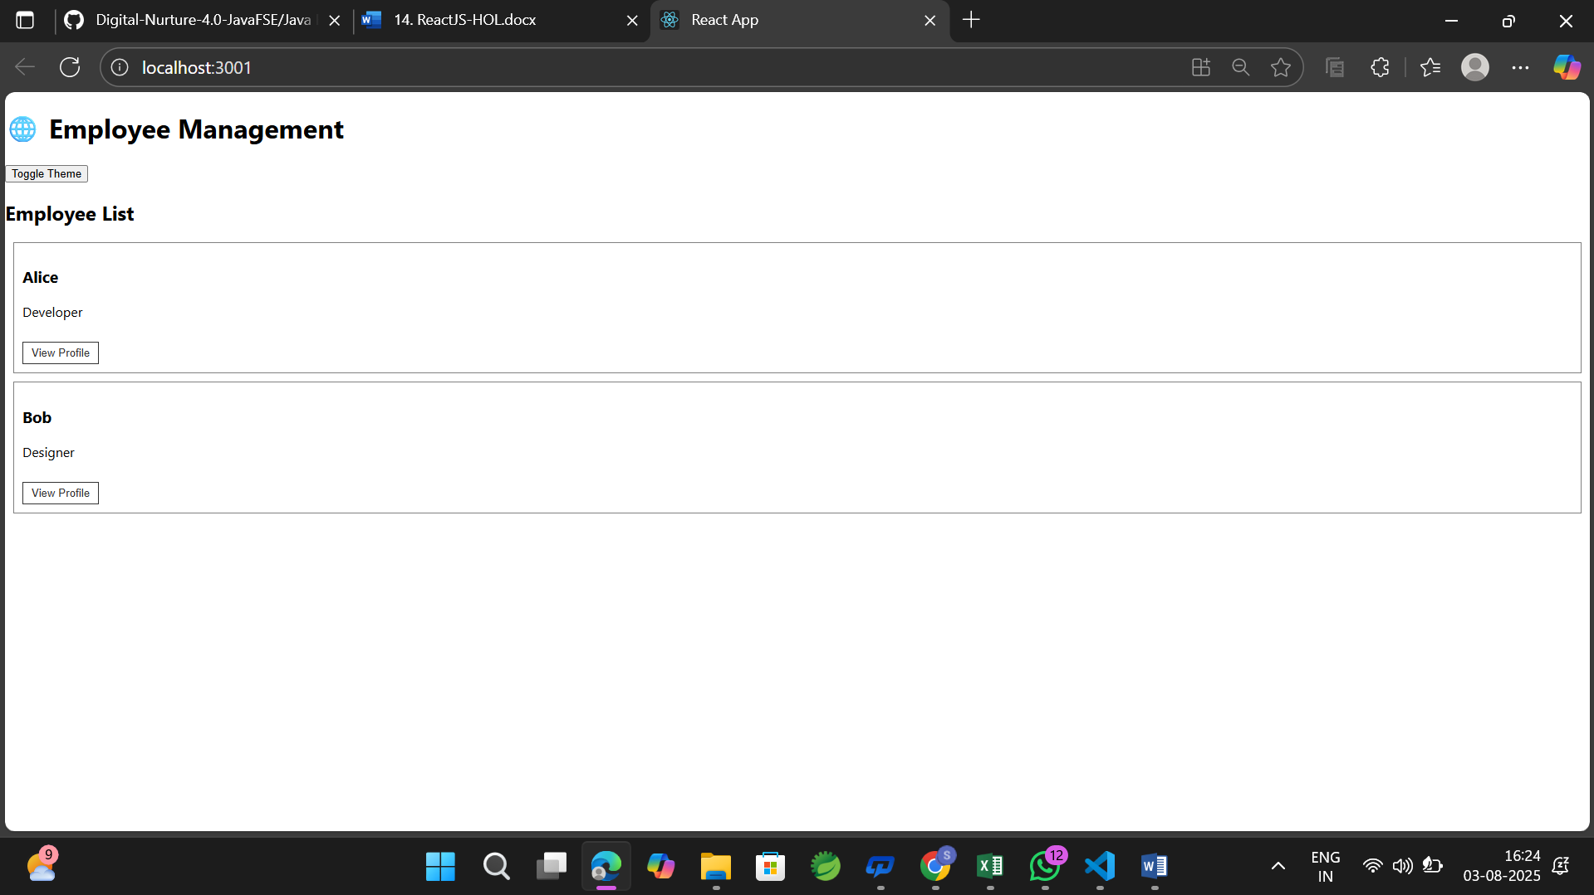
After toggling:
